**GETTING TO KNOW YOUR DUALSHOCK 4**

**LAB 1**

**SECTION 7**

**SUBMITTED BY:  
  
BENJAMIN MUSLIC  
  
SUBMISSION DATE:**

**9/8/2021**

1. **Old Computers**

|  |  |  |  |  |  |
| --- | --- | --- | --- | --- | --- |
| **Computer** | **Input** | **Output** | **Min RAM kilobytes/bytes/bits** | **Max RAM**  **kilobytes/bytes/bits** | **CPU** |
| **MITS Altair 8800** | Switches | Front Panel LED’S | .256/256/2048 | 64/64000/512000 | Intel 8080, 2.0MHz |
| **MOS KIM-1** | Hexadecimal Keypad | 6 Digital LED Display | 1.024/1024/8192 | N/A | MOS 6502, 1MHz |
| **Apple 1** | Keyboard (not included) | Composite Video | 4/4000/32000 | 64/64000/512000 | MOS 6502, 1.0MHz |
| **IBM Personal Computer (PC) 5150** | Keyboard | 80 x 24 Text display | 16/16000/128000 | 640/640000/5120000 | Intel 8088, 4.77MHz |
| **Apple Macintosh** | Keyboard Mouse | 512x342 Monochrome screen  Printer (if used) | 128/128000/1024000 | Later: 512/512000/4096000 | Motorola 68000, 7.83 MHz |

1. **Base Conversions**

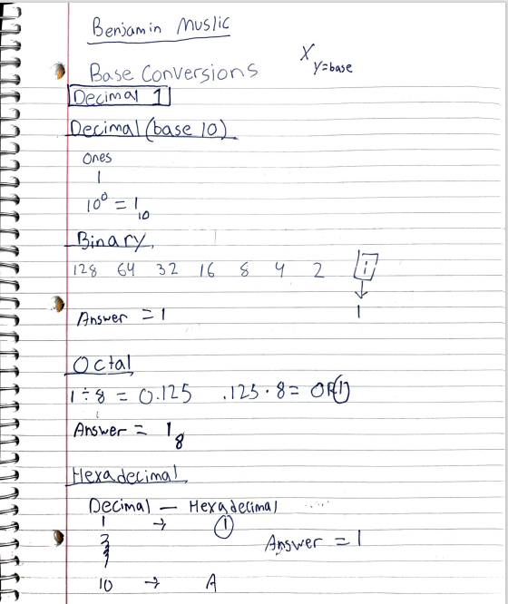

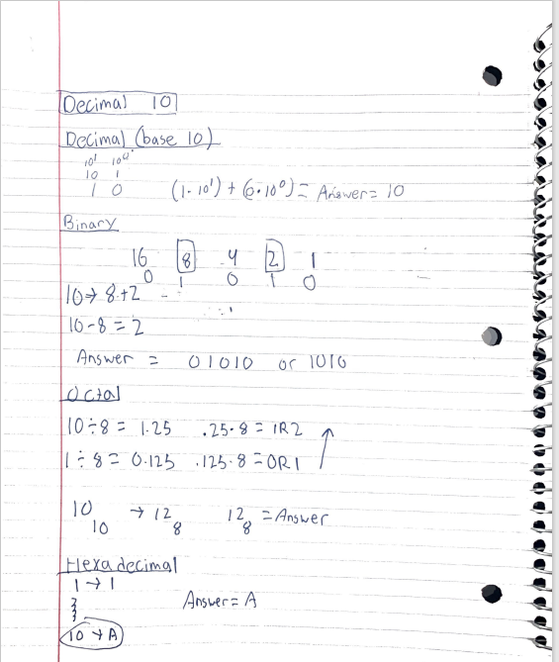

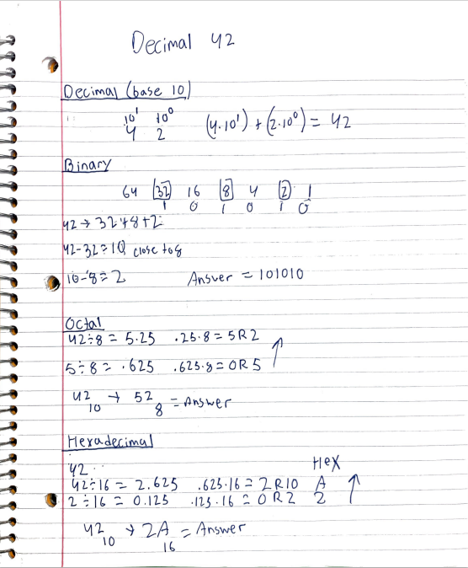

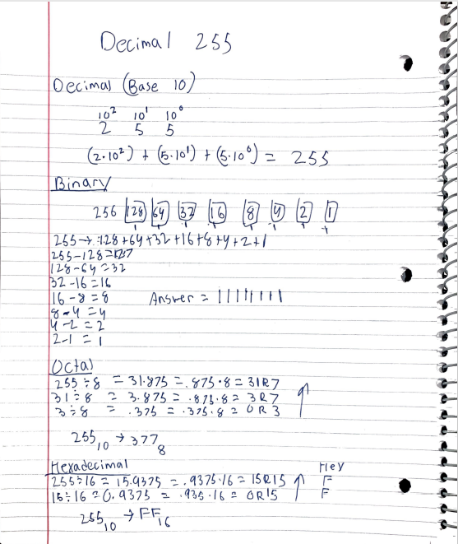

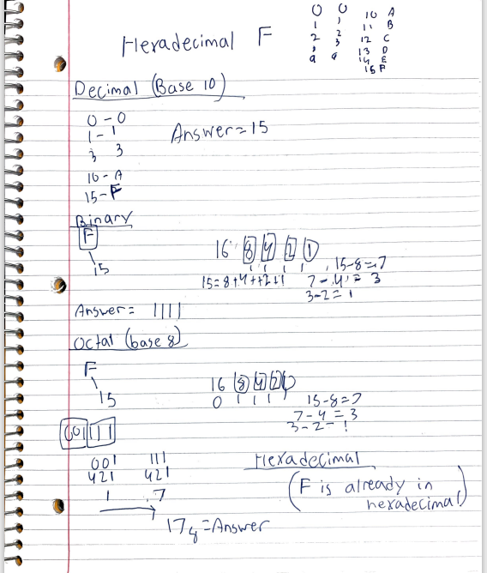

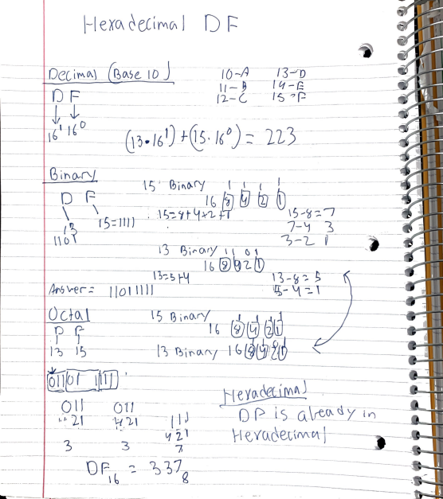

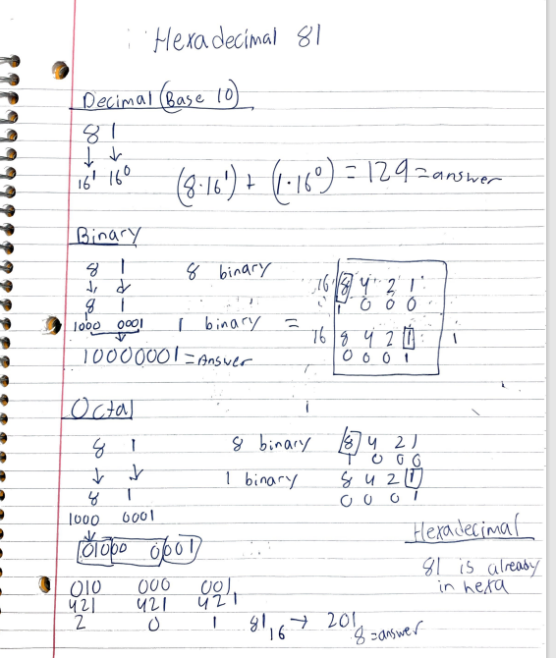

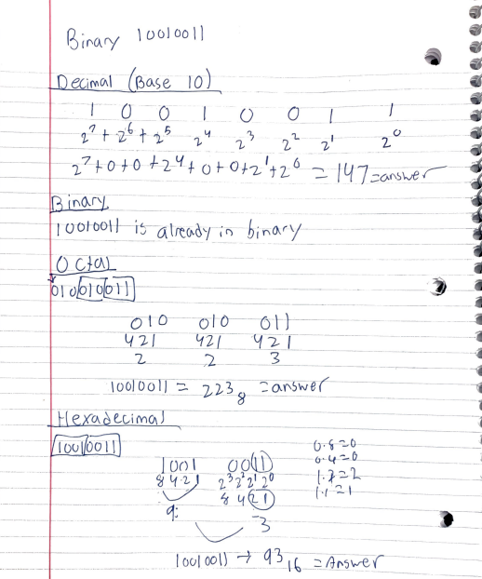

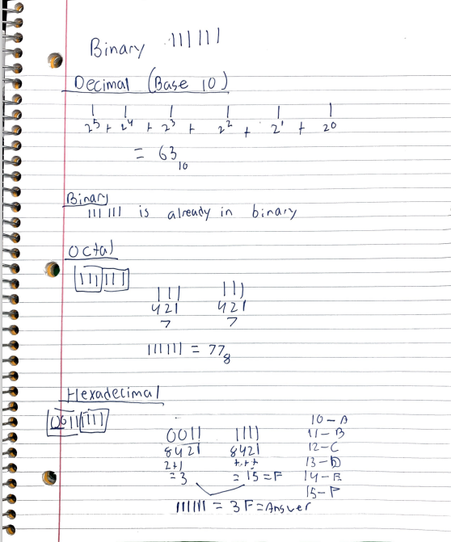

1. **Exploration**

The following graphs are gyroscopic reading of the controller in different positions:

X,Y, and Z represent the values. There are three variables because there are 3 gyroscopic axis within the controller that activate and output numbers when positioned a certain way.

**Flat 1**

The chart below is the logging when the controller is placed flat on the table

There is not as much movement along the curves but it is surprising to see that there are values being inputted despite no movement.

**Flat 2**

The chart below is the logging when the controller is turned over (while holding)

The position of Y has changed which means that the controllers tilt most likely engaged one of the axis.

**Front 1**

The chart below is the logging when the controller is turned over (light bar side up)

The position of Z has changed which means that the controllers tilt most likely engaged one of the axis.

**Front 2**

The chart below is the logging when the controller is turned over (light bar side down)

The position of X,Y has changed which means that the controllers tilt most likely engaged two of the axis.

**Custom 1**

The chart below is the logging when the controller is moved around as it were being used

This scenario and the following shows all variables (axis) in alternating positions. They are logged in the graphs accordingly.

**Custom 2**

The chart below is the logging when the controller was moved left and right

**What do you think each column of data represent?**

The axis represents the gyroscopic values produced by the on-board gyroscope within the controller.

**How does this relate the flags (-t and -g) that you used?**

These values are represented within the execution with “t” representing time and “g” representing the gyroscope.

**What unit of measure are the data in?**

Volts

**4. Joystick Calibration**

**What are you vertical and horizontal joystick equations? Are they similar or not? Why or why not?**

**and**

They are similar because they both have an x value that represents the current position of the joystick. That x value is then divided by positive or negative 128 (representing the maximum input value the joystick can output) and the number (which is less than 1) is inputted in for example a game. The output would of course be the movement of the camera in the game. They are also similar because within the joystick there is no value beyond 128 or -128.

**What did you find as the center point?** It is around .18

**Explain why it is or is not 0?**

The center point I believe is very hard to obtain zero because that would mean it would have to be perfectly still. There was movement even if it was not noticeable and this is proved by the values.

**What could cause the center to not be 0?**

Defective equipment or damage with improper use. The farther the value is from zero the more noticeable is the lack of accuracy when using the joystick.

**What could you change to make the center be 0?**

Depends on one’s skill level when it comes to wireless controller technology. An experienced individual would most likely be able to use complicated techniques to recalibrate the joystick to its perfect value. A lot of modern games have built in software to make the center be as close to 0 as possible. In that case, that is why the character does not move. If the center is off exceptionally, maybe the consumer can take advantage of the manufactures warranty as the controller most likely as a defective gyroscope or accelerometer.